Please read through the following to introduce yourselves to the programe. First we have a slide on where SMART friends and family came from:

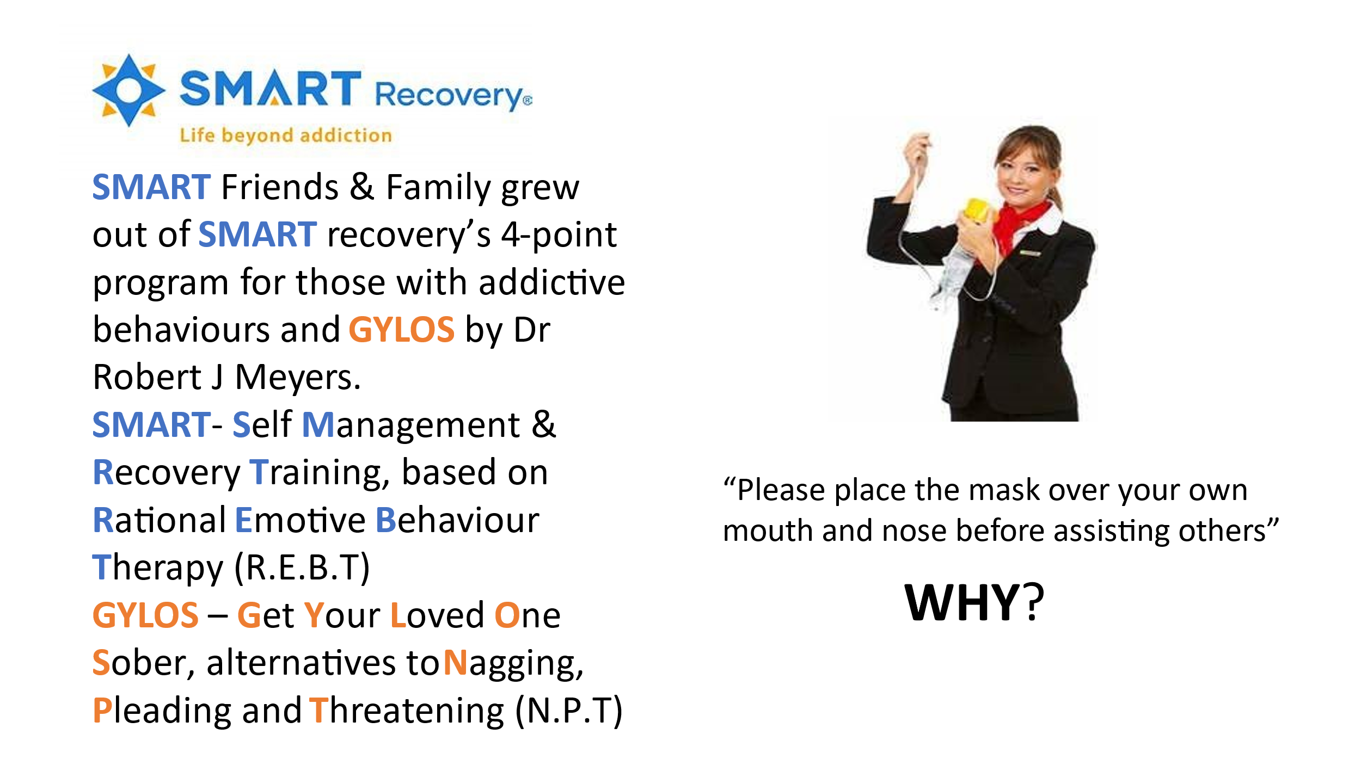

The reason should be obvious – if you don’t put your mask on before assisting someone else, you will both collapse! This is the same in our relationships with our loved ones (LO’s) – we need to be healthy before we can give to our LO’s.

Next we have the opening statement read out at all meetings

*“Welcome to this meeting of SMART recovery for Family & Friends.*

*In these meetings we help ourselves and each other live more fulfilled and better lives.*

* *We will focus on solutions or what will make our lives better & happier, rather than bad things that have happened in the past.*
* *We will keep in mind that we are not responsible for the behaviour of our Loved Ones.*
* *We believe that although people may have a problematic habit, they are more than just their behaviour, so we avoid labels, such as alcoholic or addict in our meetings.*
* *We do not see ourselves or our Loved Ones as ‘powerless’ over addiction. Instead, we focus on the power of choice, our ability to change our lives and make them better. There are no guarantees, but we often find that changing our behaviour has a positive effect on our Loved Ones.*
* *We strive to be patient but persistent in our efforts to improve our lives. It takes time to change beliefs and develop new ways of behaving around our Loved Ones.*

*Please attend meetings for as long as they are helpful. In our meetings, you will find people in all stages of recovery. As no two meetings are ever alike, do try to come to a few before you decide how helpful SMART can be for you.*

*Thank you all for being here and we look forward to your participation to make this a great meeting.”*

Our next section is called **Disable the Enabling**. Think about the following statement:

**“Your words may be to the contrary, as you scold, nag, beg, plead, but your behaviour shouts: “I’m here to make it easier for you “**

**Ask yourself the following questions – are you an enabler of your LO’s addiction? Do you need to resign your job as manager of your loved ones addiction.**

The questions below are examples of behaviours that often serve to prevent someone from experiencing the natural consequences and repercussions of their choices to continue with the addiction. Mark each of these as True or False:

____Have you paid bills that your Loved One (LO) was supposed to have paid?

____Do you avoid talking about your LO’s drinking or drugging out of fear of the response?

____Have you threatened to leave if your LO didn’t stop drinking and then did not leave?

____Have woken your LO so he or she would not be late for work or school?

____Have you explained, (multiple times) to your LO that he or she MUST stop

drinking/using?

____Have you bailed your LO out of prison or paid his or her legal fees?

____Have you ever helped your LO look for items they lost while drinking or using?

____Have you ever avoided making plans to spend time with family or friends because you

were concerned your LO’s behaviour would be unpleasant due to drugs or drinking?

____Have you ever cut back on your own expenses because of your LO’s substance use?

____Do you believe your LO’s lies - over and over?

____Do you accept your LO’s excuses?

____Do you allow yourself to be physically or emotionally abused by your LO?

____Do you make addictive behaviour seem “normal” to your children?

____Do you let your LO change the subject when you bring up their substance abuse

problem?

____Do you nag/plead/threaten your LO in an effort to inspire change?

____Do you keep your LO’s addiction a secret from others?

**Disabling the Enabling Exercise**

How can you overcome your impulses to fix, nag, and protect?

Start by making a list of specific things that you do that you suspect may be enabling. Now that you are aware of some behaviours that you might want to change.

Ask Yourself:

1. Why am I doing these things? What am I telling myself about this situation that has been making it ok for me to do these things? Some things that you may be telling yourself:

My LO needs my help (and I MUST help him/her)

I can't be happy until my LO changes

It hurts me to see this

I’m the only one my LO trusts to help him/her fight this addiction

2. Has my behaviour been effective in solving the problem?

3. What’s stopping me from changing my enabling behaviours? For example:

I don't want to hurt my LO

They will be angry with me

It's going to hurt ME to no longer protect my child

I just don't see how it will make any difference

4. Challenge your reasons for continuing your enabling behaviours

Will disabling the enabling truly hurt my LO? Yes, they may get angry, but what is that in comparison to the long-term HARM of addiction that I am working to avoid?

What will hurt ME more: disabling the enabling, or knowing that I didn’t do anything to stop it?

What can I expect to happen if I don't change? Will things get better?

5. Choose an enabling behaviour that you’d like to change. Use the Change Plan Worksheet to plan how you will implement your change. Consider which SMART tools might be helpful to you in planning your new behaviour (e.g. positive communication, assertive communication, healthy boundaries).

Change Plan Worksheet

Planning is a key to making successful changes. Use this worksheet to develop your own plan for making a change in your behaviour.

1. The change I want to make is:

2. The most important reasons why I want to make this change are:

3. The steps I plan to take in changing are:

4. The ways other people can help me are:

Person: Possible ways to help me:

5. I will know that my plan is working if:

6. Some things that could interfere with my plans are:

7. How important is it that I make this change:

Not at all Important Most Important

1 2 3 4 5 6 7 8 9 10

8. How confident am I that I can make this change?

Not Confident Very Confident

1 2 3 4 5 6 7 8 9 10

Communication with our LO’s is the next key area to consider. Dysfunctional ways of communicating can set in and last for decades if were not careful. We must always try to be the adult in the relationship – adult to adult is what we are looking for. Think about communications as ‘I win, you win’, rather then a conflict of ‘I win, you lose’

**Positive Communication**

**“The way you talk to your loved one not only reflects how you feel about them, but also sets the tone of their reactions to you”**

Four important areas of interpersonal communication are often abandoned when relationships run into hard times. The acronym PIUS can be used to help remember how to get our communication back on track. **P**ositive, ‘**I**’ Statements, **U**nderstanding, **S**hare.

**Be POSITIVE**

Include positive comments in your conversation (and avoid negative comments). This not only helps the listener but helps your remember that you do appreciate something about the other person. Think of something that you really like about them or just tell them you love them. Become conscious of those things that you tend to communicate in a negative way and reframe them using positive phrasing (i.e. say what you want, not what you don’t want).

**Use “I” statements**

The “I” statement is one of the best communication tools that we have. It helps us to speak to another person in a way that communicates our needs or wishes without blaming or criticising the other person. When others feel blamed or criticised, they usually become defensive.

“I feel”. When you communicate your feelings you have a choice. Blaming your LO (e.g. “you make me so mad”, “you always make me sad”) will put them on the defensive. Accept responsibility for your feelings when communicating with your LO (e.g. “When you drink, I feel sad and worried”)

“I want”. Let your LO know what you would like from them in place of a current behaviour. Make your request reasonable and something your LO can actually do. (e.g. “I would like it if you could call me if you will be late for dinner”. “I would like it if we could spend time together going to the cinema or out to eat”)

**Be UNDERSTANDING**

Show your LO that you care about them and respect them enough to try to understand their point of view (even if you do not agree with it). LISTEN to them. REALLY LISTEN! Ask questions; reflect back what you hear in a non-judgmental tone. Understanding your LO’s point of view will make it easier for you to find some common ground. When you show that you are trying to understand something about another person, they are more likely to accept that you have something important to share with them.

**Accept and SHARE responsibility**

Neither one of you is perfect. Understanding and acknowledging your part in the problem goes a long way in breaking out of the pattern of conflict.

**Communication Styles**

Generally speaking, communication can be characterised by four different styles. Tick all those which one do you most frequently use to deal with conflicts in your relationships?

1. Passive communication

Not standing up for your rights

Not setting limits or boundaries on another’s behaviour

Continually putting other’s needs before your own

Taking on the role of “martyr”

Not being able to say “no”

2. Aggressive Communication

Bullying and intimidating others to get what you want

Threatening people

Ignoring the needs and rights of others

Shouting, yelling, screaming or physically abusing others

3. Passive-Aggressive Communication

Indirectly communicating – e.g. slamming doors; giving the “silent treatment”; saying something that is designed for your Loved One to hear without saying it to them directly

Using sarcasm/put downs

Using humour to be nasty or hurtful

4. Assertive Communication

Being direct and honest

Being able to negotiate – having a sense of give and take

Asking for your own needs to be met, while respecting the needs of others

Being able to say “no” and set limits

Being able to acknowledge when you are in the wrong

**Planning a Conversation Using PIUS**

Think about the statements below and fill in some ideas in the spaces provided.

What specific behaviour do I want to address?

When would be a good time(s) for this conversation?

Positive statements

I statements

Understanding (listen, ask questions, reflect back what you hear)

Accept and share responsibility

End with a Positive statement

The last important area to consider are our **Boundaries**.

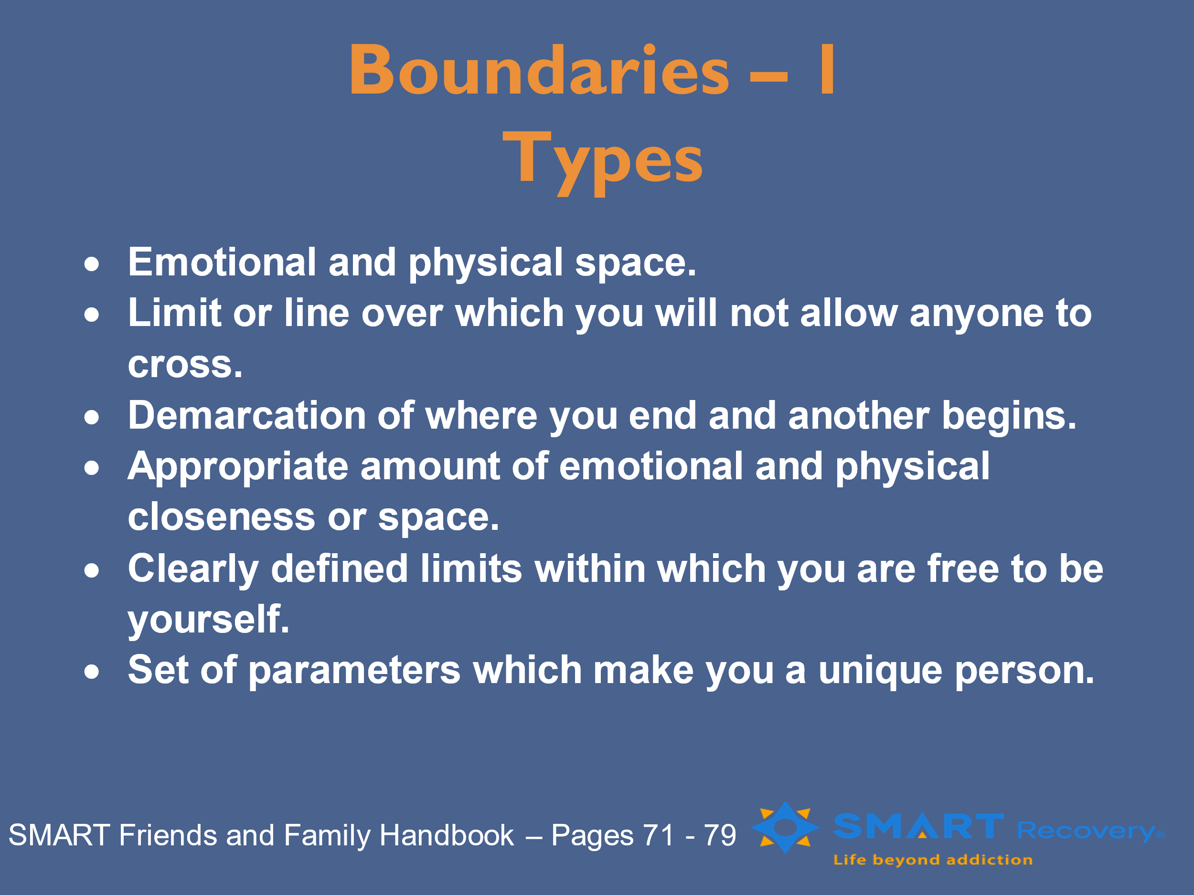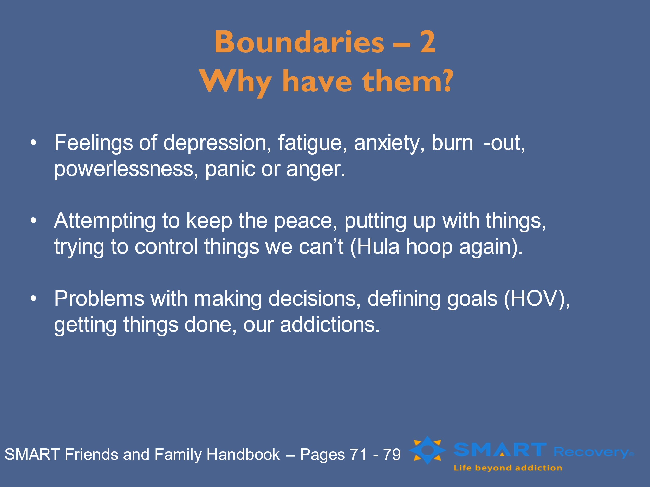

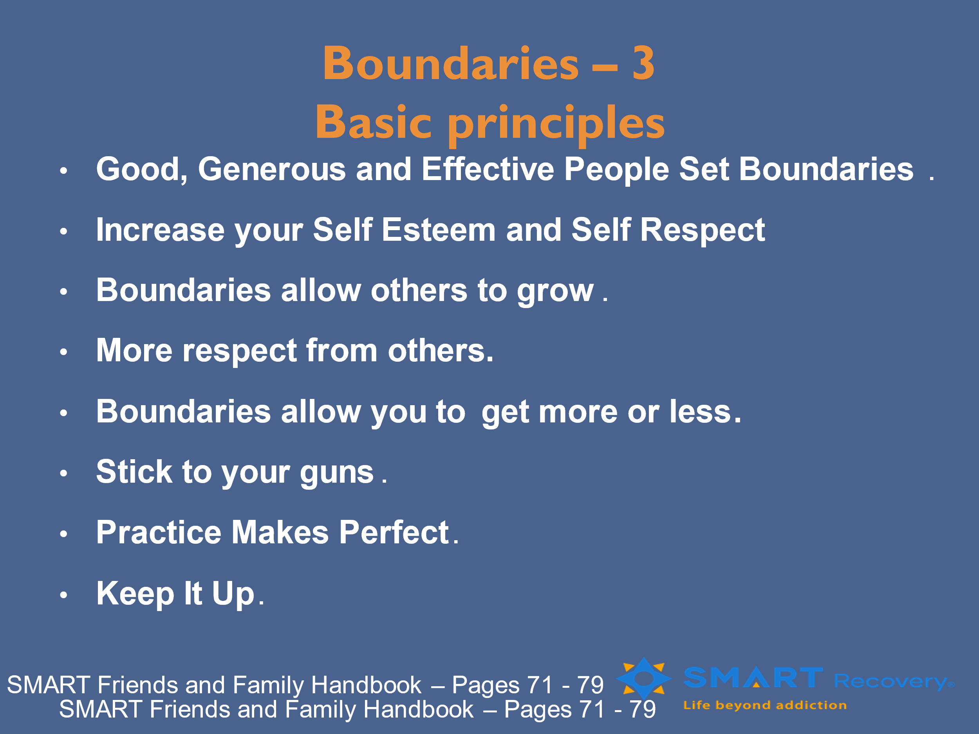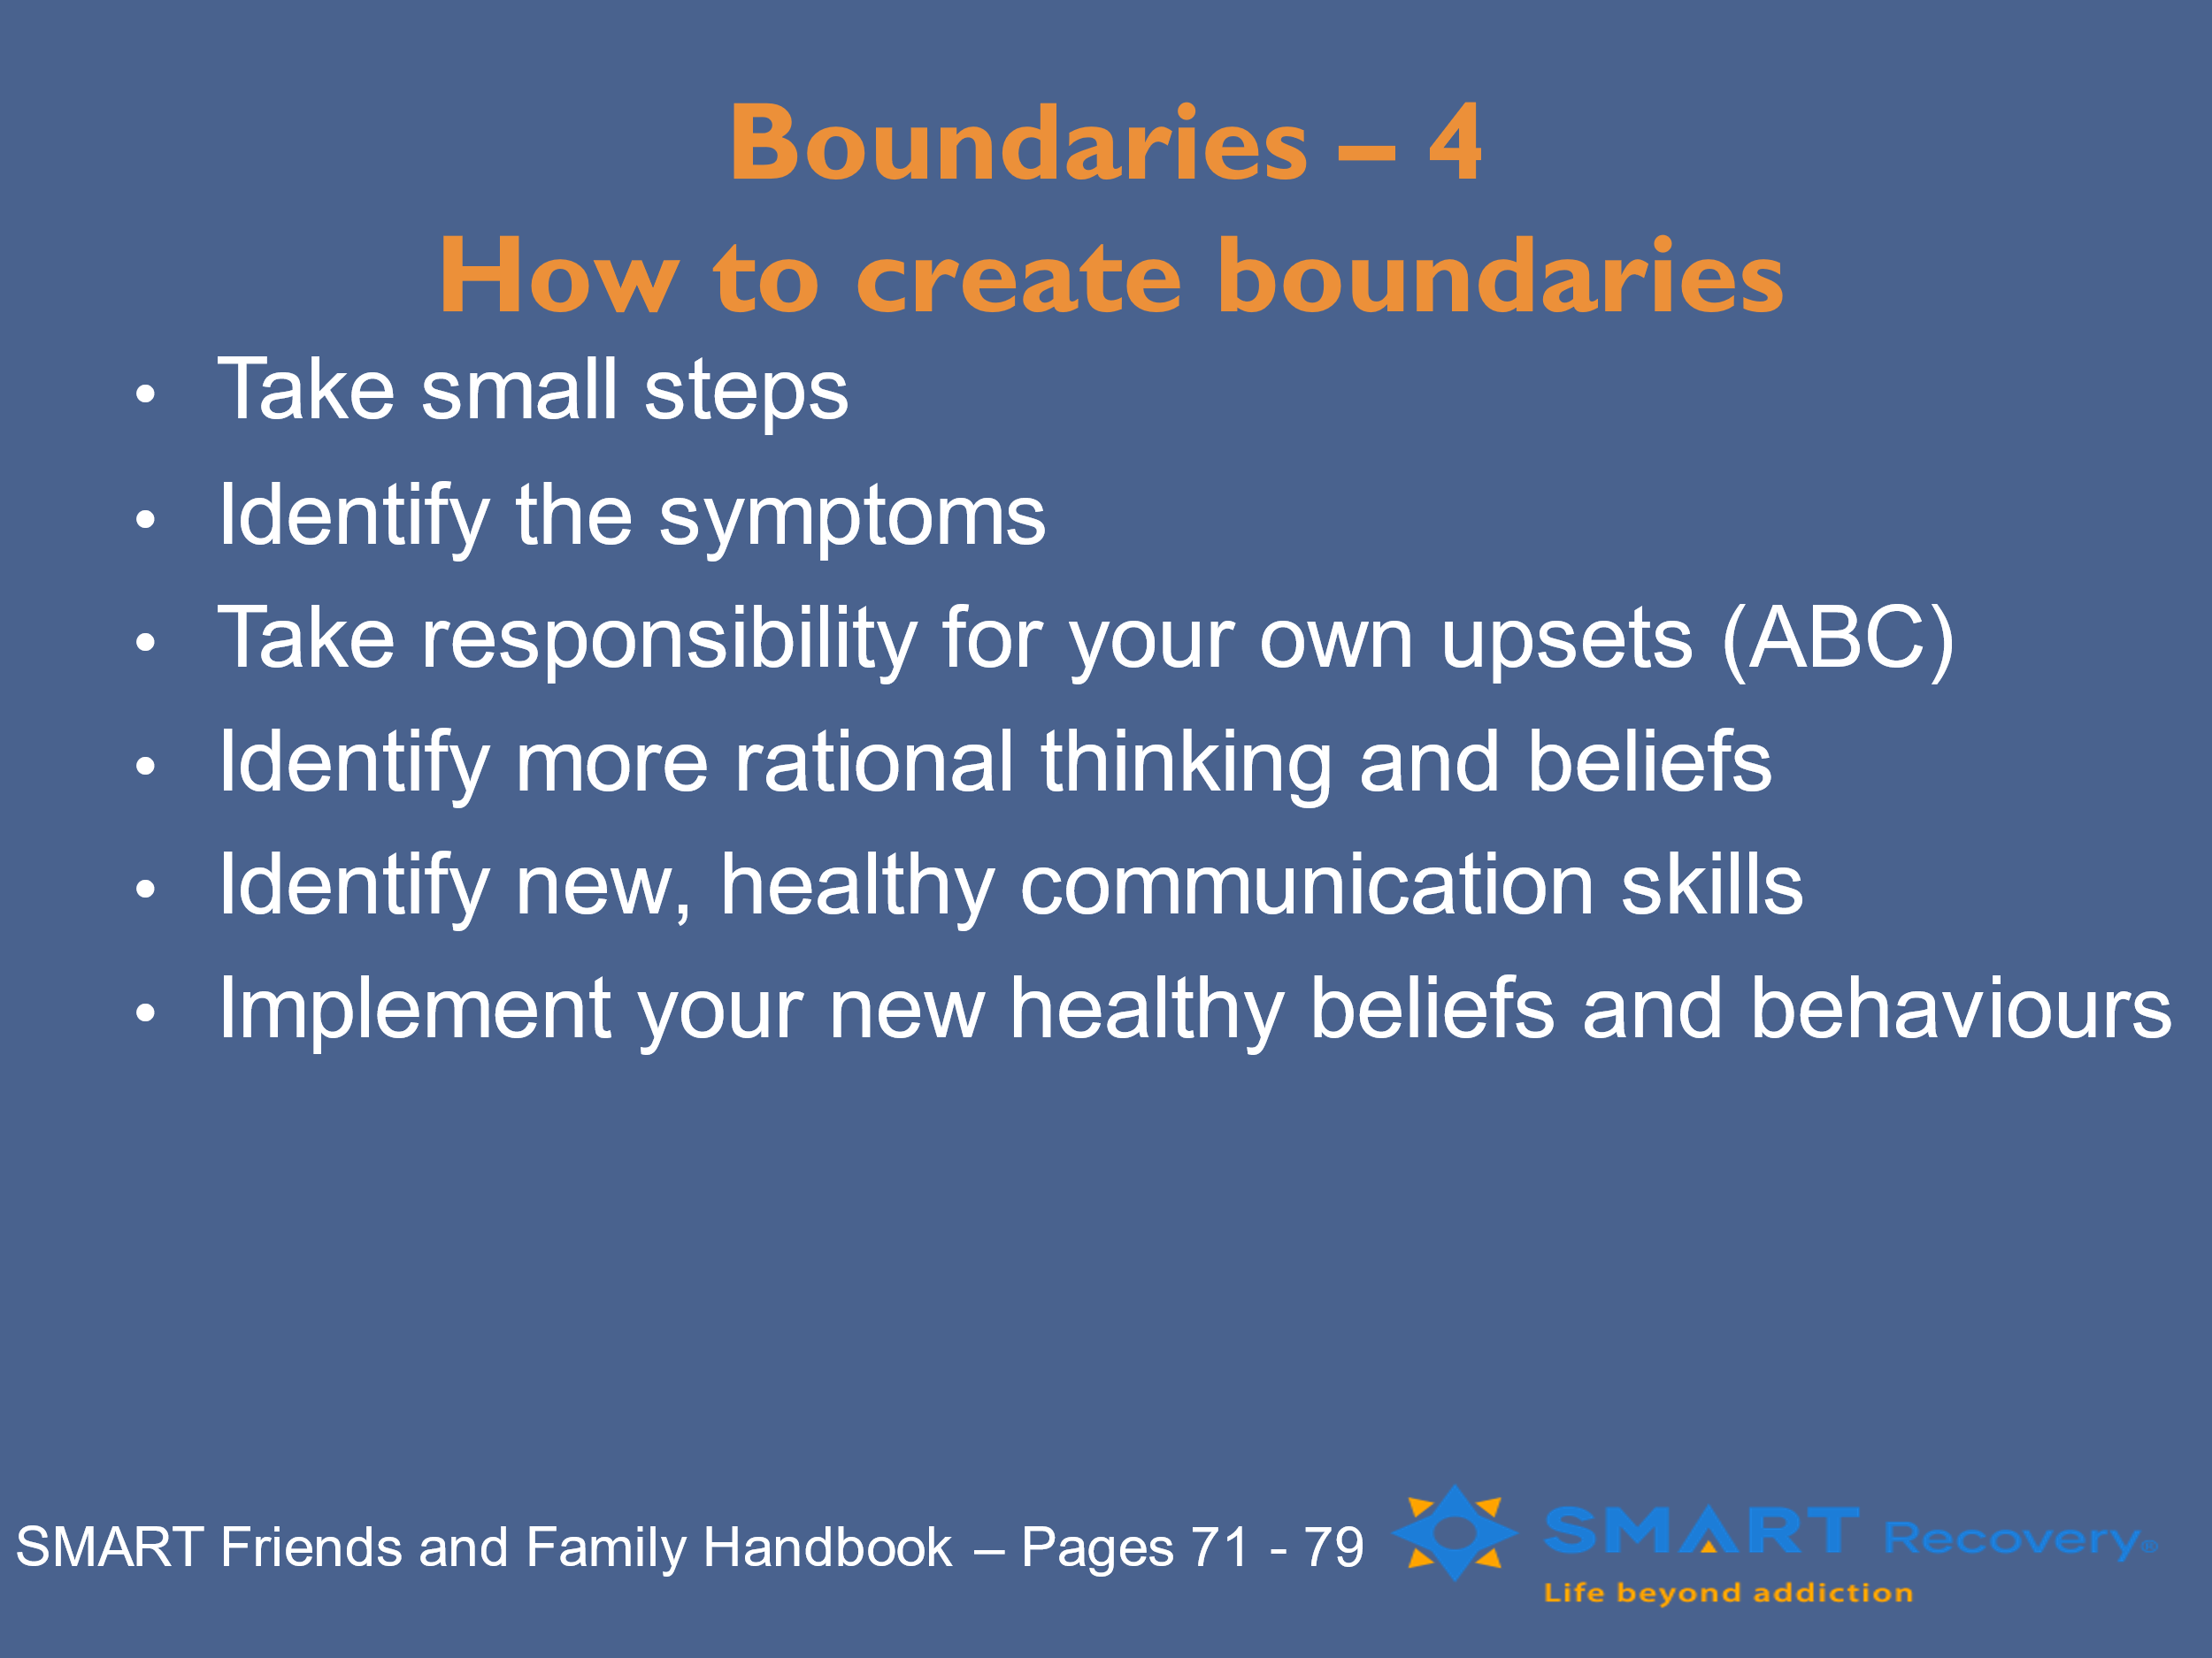

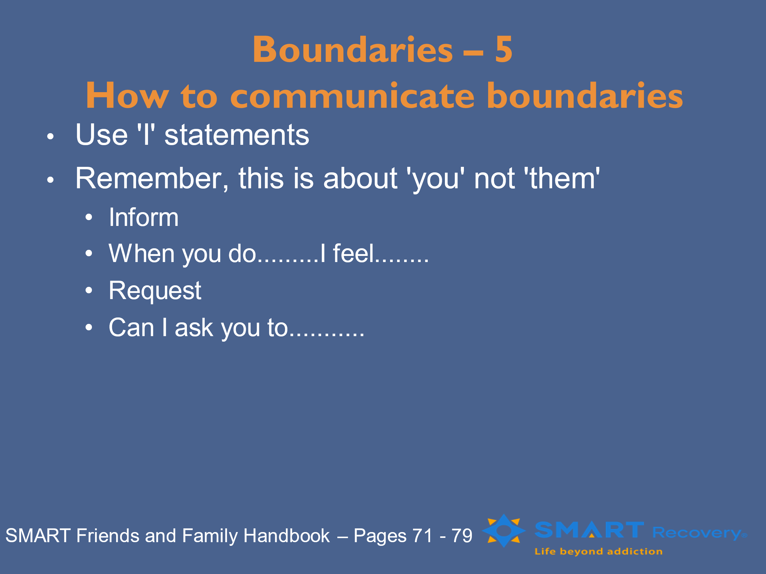 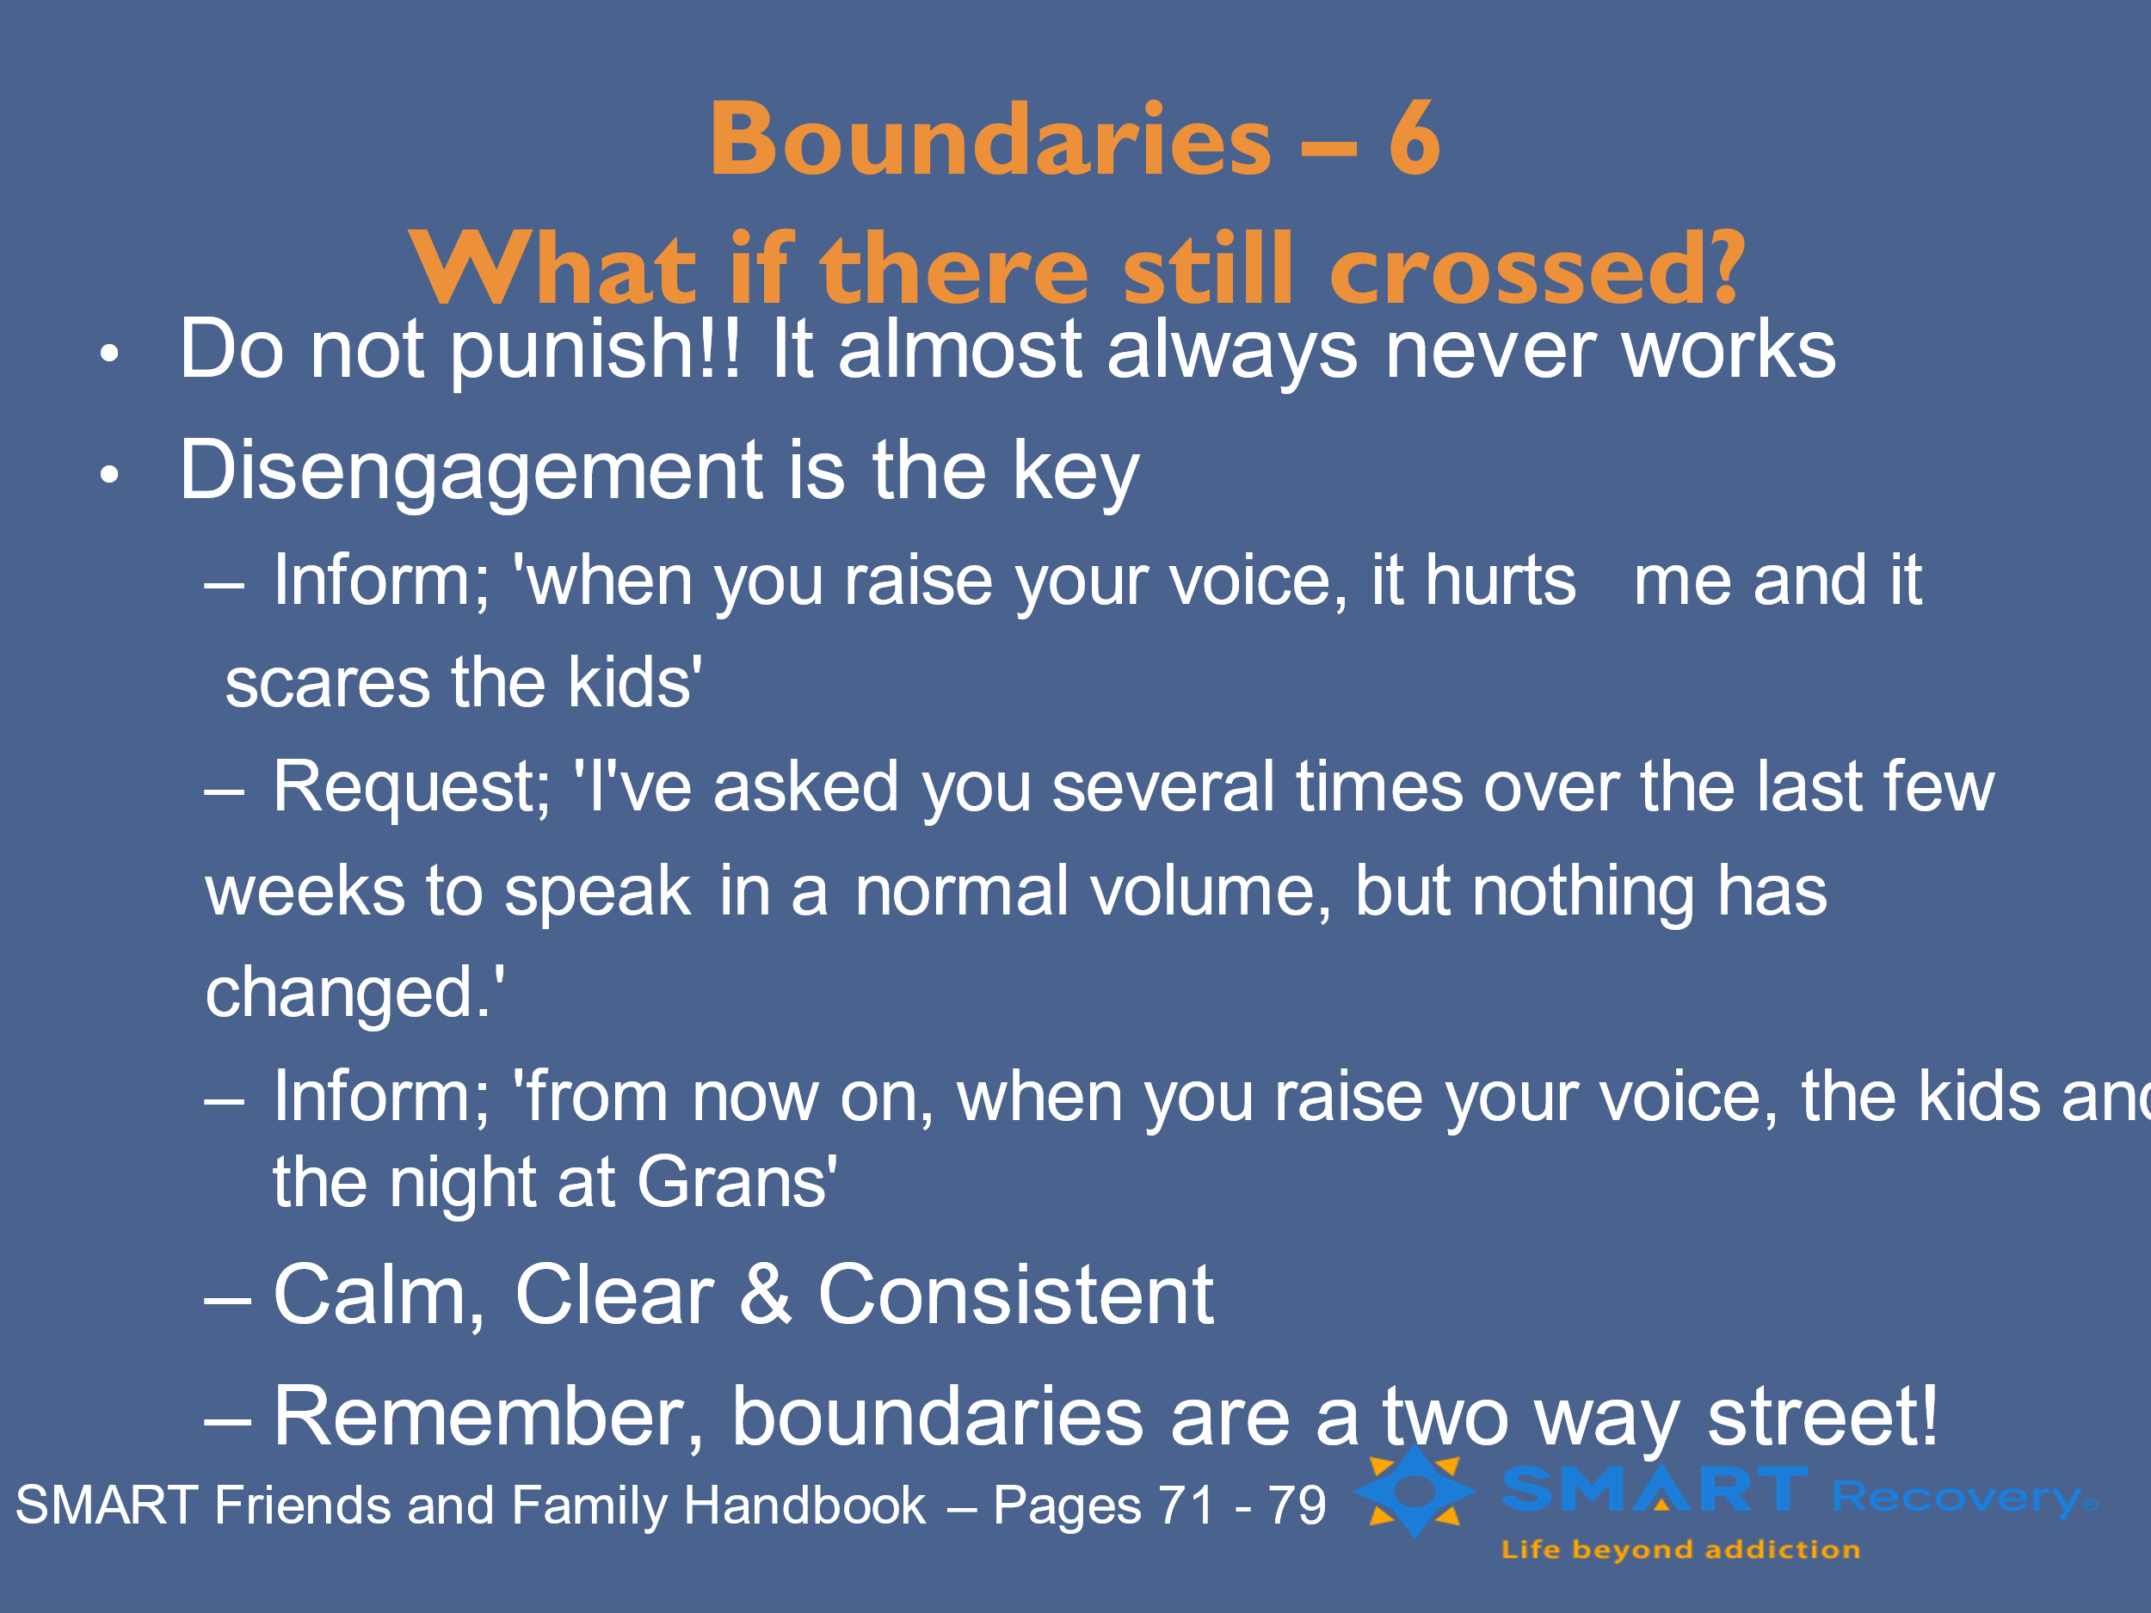

Boundary Questionnaire

True or False:

___ I loan money to my Loved One (LO), but often do not get repaid. *

___ I am supporting someone financially who should be able to support him/herself. *

___ My LO lies to me, covers up the truth of their activities. *

___ I fail to speak up when I am being treated poorly. *

___ I frequently agree to do things in order to keep the peace, or to please others. *

___ My LO has been responsible for causing damage or theft of my property. *

___ I give and give and give in this relationship, and in return, I get less and less and less. *

___ I don’t give any thought to my own happiness. **

___ My LO sometimes disappears for long periods of time without making contact. *

___ I frequently feel angry in response to my LO’s behaviours. *

___ I feel like I can’t make plans, because my LO is so unpredictable. *

___ My LO puts lives at risk by driving while under the influence. *

___ I can only be happy if my LO is doing well. Otherwise I’m anxious.**

___ My LO is emotionally unavailable much or all of the time.*

___ My LO does not accept responsibility for any household chores. *

___ I don’t feel like I’m thriving, only surviving.**

___ My LO is verbally or physically abusive. *

___ My LO expects me to be a backup alarm for work/school if they oversleep. *

___ My LO doesn’t clean up after him/herself. *

___ My LO does not follow through on promises. *

* Your boundaries may be being crossed by another

** You may be crossing your own boundaries